**PHASE 3**

**3.2Write SQL query to find the highest number of rapes & Kidnappings that happened in which state, District, and year.**

SELECT

“STATE/UT “,

MAX(Rape) AS MAX_RAPES,

MAX( “Kidnapping and Abduction “) AS MAX_KIDNAPPINGS,

Year

FROM

42_district_wise_crimes_committed_against_women_2001_2012

GROUP BY

“STATE/UT “,year

ORDER BY

MAX_RAPES DESC,

MAX_KIDNAPPINGS DESC

LIMIT 1;

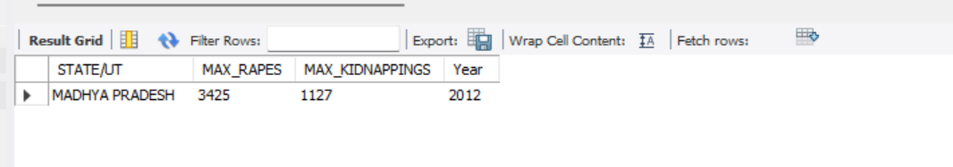

**3.3Write SQL query to find All the lowest number of rapes & Kidnappings that happened in which state, District, and year**

SELECT

“STATE/UT “,

DISTRICT,

YEAR,

MIN(Rape) AS MIN_RAPES,

MIN( “Kidnapping and Abduction “) AS MIN_KIDNAPPINGS

FROM

42_district_wise_crimes_committed_against_women_2001_2012

GROUP BY

“STATE/UT “,

DISTRICT,

YEAR

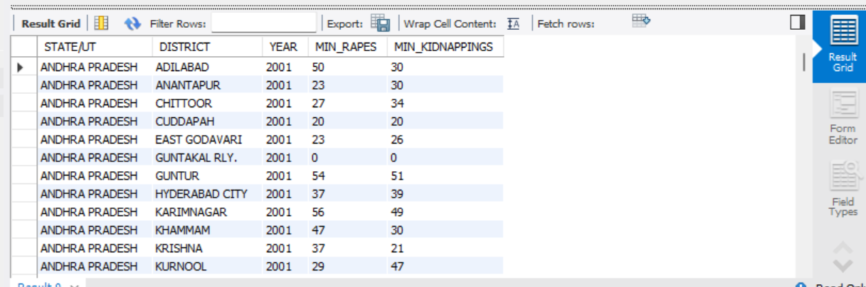

**3.5Write SQL query to find the highest number of dacoity/robbery in which district.**

SELECT

`STATE/UT`,

DISTRICT,

Year,

MAX(Dacoity) AS Max_Dacoity,

MAX(Robbery) AS Max_Robbery

FROM

02_district_wise_crimes_committed_against_st_2001_2012

GROUP BY

`STATE/UT`,

DISTRICT,

Year

ORDER BY

GREATEST(Max_Dacoity, Max_Robbery) DESC

LIMIT 1;

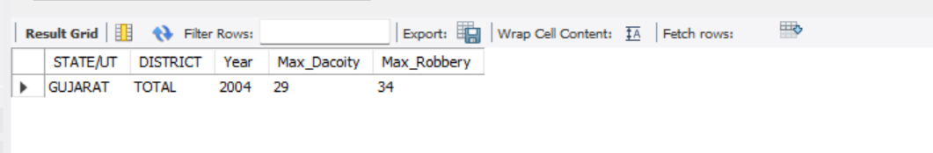

**3.6Write SQL query to find in which districts(All) the lowest number of murders happened.**

SELECT

`STATE/UT`,

DISTRICT,

Year,

MIN(Murder) AS Lowest_Murders

FROM

02_district_wise_crimes_committed_against_st_2001_2012

GROUP BY

`STATE/UT`,

DISTRICT,

Year

ORDER BY

Lowest_Murders ASC;

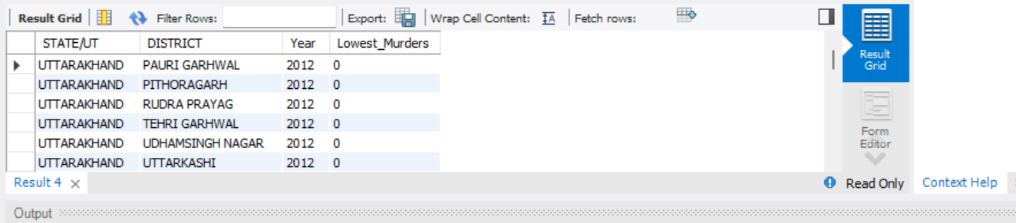

**3.7 Write SQL query to find the number of murders in ascending order in district and yearwise.**

select District, Murder, year

from 02_district_wise_crimes_committed_against_st_2001_2012

order by District, year asc;

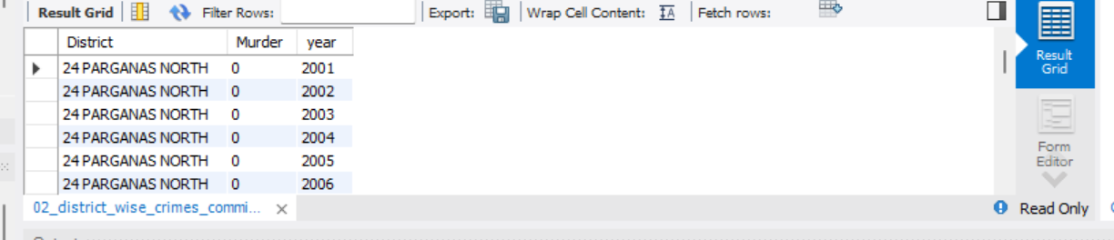

**3.8.1 Insert records of STATE/UT, DISTRICT, YEAR, MURDER, ATTEMPT TO MURDER, and RAPE columns only from 01_District_wise_crimes_committed_IPC_2001_2012.csv into a new table**

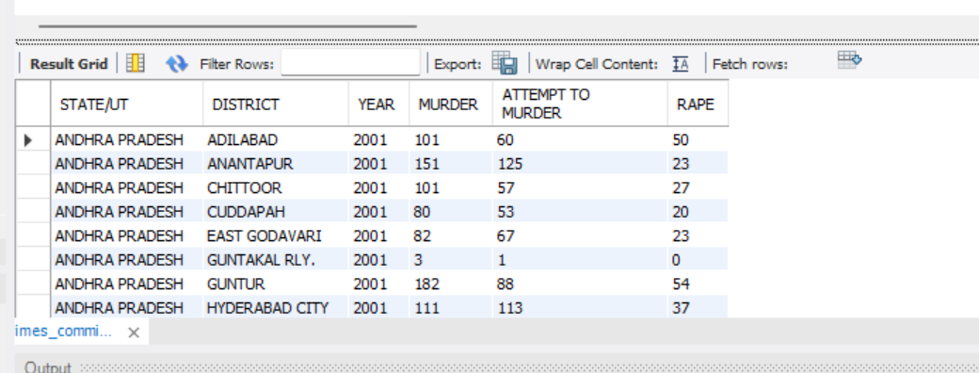

**3.8.2 Write SQL query to find which District in each state/ut has the highest number of murders yearwise. Your output should show STATE/UT, YEAR, DISTRICT, and MURDERS.**

SELECT

`STATE/UT`,

district,

murder AS murders,

year

FROM (

SELECT

t.`STATE/UT`,

t.district,

t.murder,

t.year,

DENSE_RANK() OVER (PARTITION BY t.`STATE/UT`, t.year ORDER BY t.murder DESC) AS rnk

FROM

01_district_wise_crimes_committed_ipc_2001_2012 AS t

) AS ranked

WHERE

rnk = 2;

